Cooler, Mobile Barrel-Style Beverage  70qt (red) qty 3

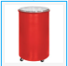

Cooler, Mobile Cart-Style Beverage 65qt (red) qty 3  
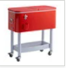

Cutting Boards, Polyethylene 24" x 18.75" (white) qty 20



Merchandising Rack, Black Epoxy 5-shelf, Angled Mobile (18x24x69), qty 3

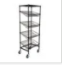

Holder, Shelf Label 3x19/16", qty 20

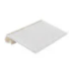

Shelf Divider, Black Epoxy, 18" x 8" qty 15

