September

**2023**

08

Fall

|  |  |  |
| --- | --- | --- |
|  | Macintosh HD:Users:coreyryan:Desktop:Resources:lamp_blue.png  **HCISD** | |
|  | culinary art redesign Equipment quote | |
| **Prepared by** Career & Technical Education Department  **A Work in Progress** | **Email** raul.alvarez@hcisd.org |

Harlingen Consolidated Independent School District 407 N 77 Sunshine Strip Harlingen, TX 78550

**Requesting a Quote from for company for the following Culinary Equipment (Equal or similar to)**

[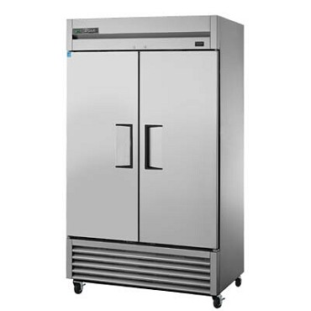](https://www.jesrestaurantequipment.com/assets/images/products/true/true-t-43f-hc%20reach-in-freezer.jpg)

1. **One (1) – Commercial Refrigerator**

Example: True T-43F-HC - Refrigerator, two-section, solid doors, stainless steel front

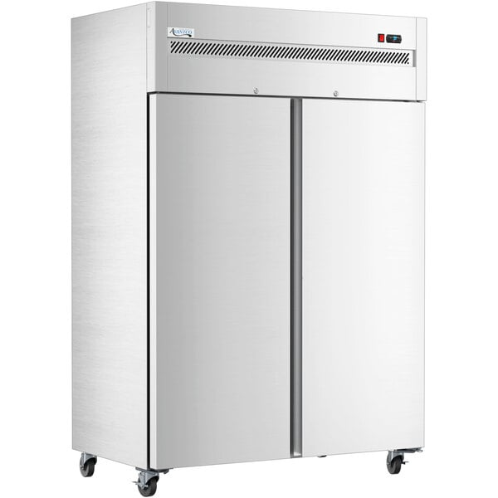

1. **Two (2) – Commercial Freezers**

Example: Avantco Z2-F-HC 54" Solid Door Stainless Steel Reach-In Freezer

[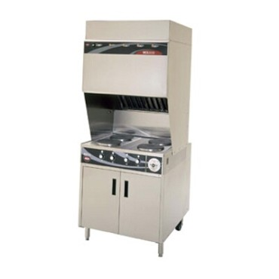](https://www.jesrestaurantequipment.com/assets/images/products/well/wells-wv-4hf-ventless-range.jpg)

1. **Two (2) – commercial vent-less electric ranges**

Example: Wells WV-4HF - VCS2000 Ventless Cooktop, electric

1. **Twelve (12) – 6’ stainless steel workbenches with bottom shelf + 16 wheel kits for 16 tables**

Example: Regency 30”x72” 18-gauge 304 stainless steel worktable with 4” backsplash and galvanized undershelf

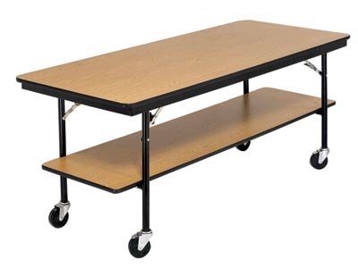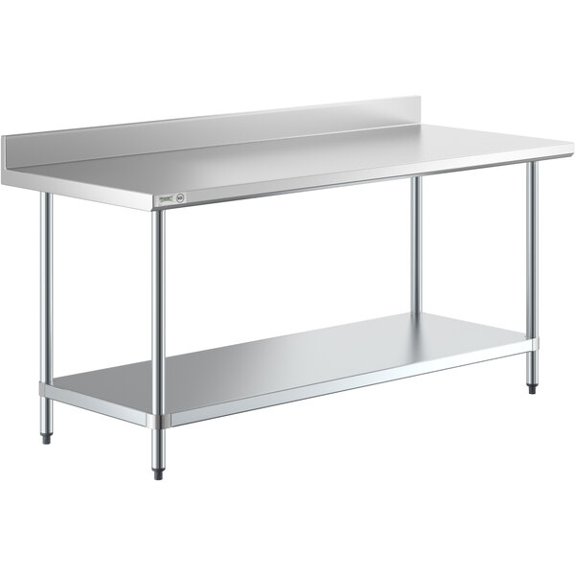

**5. Eighteen (18) – 6’ stainless steel tables no bottom shelf + 18 wheel kits for 18 tables**

Example: Advance Tabco TELAG-306-X - Work Table, 72"W x 30"D, 16 gauge 430 stainless steel top (Length 72”/Width 30”/Height 35 ½”)

[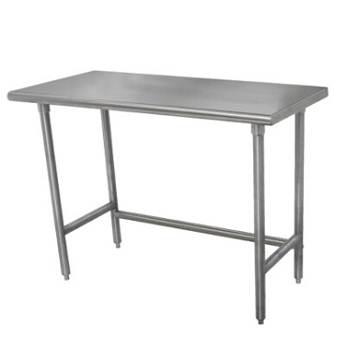](https://www.jesrestaurantequipment.com/assets/images/products/adva/advance-tabco-telag-306-x-stainless-steel-work-table.jpg)

**6. Six (6) – Single station hand Sinks and faucet**

*Example:* Advance Tabco FC-WM-2721FV 16-gauge single station hand sink with 12” deep bowl and toe operated faucet 27” x 21 ½”

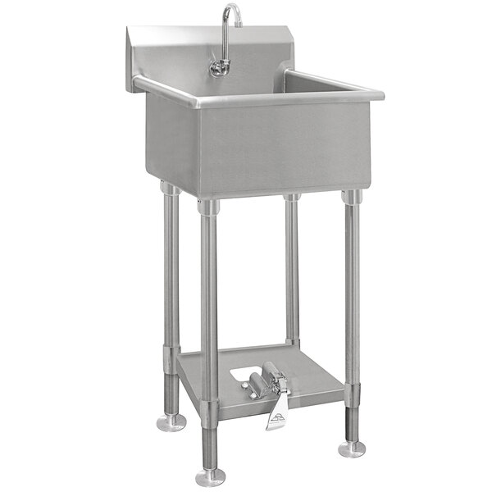

**7. Fifty-Six (56) – stainless steel stools (height 24”/width 15”/depth 15”)**

Example: Paula Brushed Aluminum Swivel Bar Stool, outdoor/indoor, backless, aluminum seat

**8. Six (6) Stainless steel shelves**

Example: Regency 15”x48” stainless steel wall mounted pot rack with shelf and 18 galvanized hooks

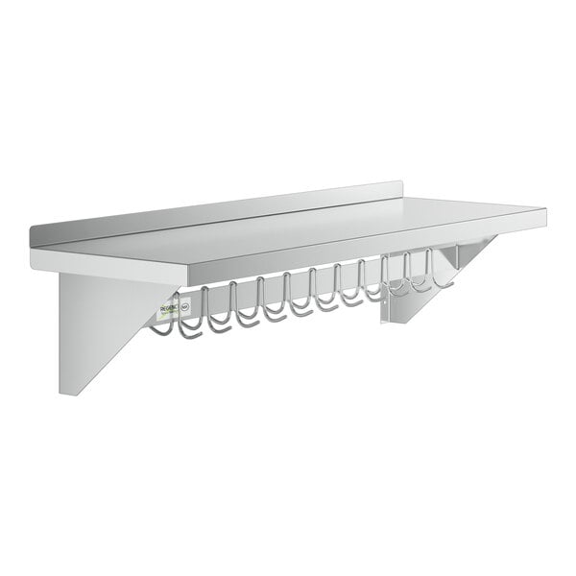

**9. Two (2) Commercial kitchen Eyewash Station**

*Example: Guardian Equipment G1814 Wall Mounted Eyewash Station with Stainless Steel Bowl*

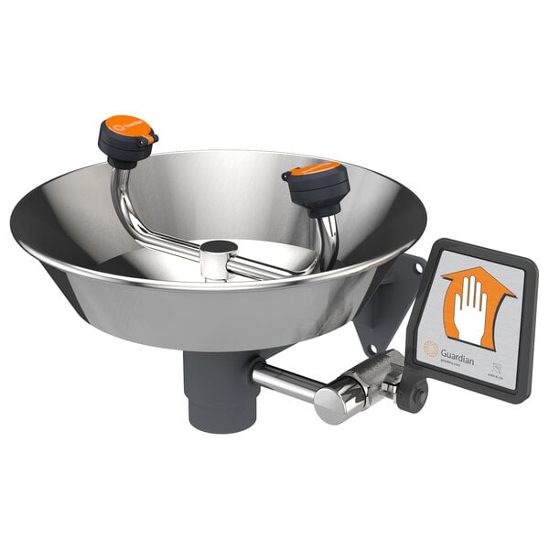

**10. Two (2) mobile Demo Table**

Example: Eagle Group mobile DT3660SE Spec-Master 60" Demo Table with Mirror

 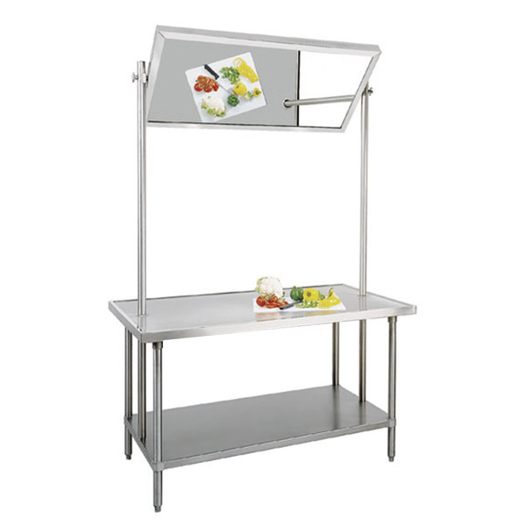

**11. Two (2) Grease Trap**

*Example: Ashland PolyTrap 4825 50 lb. Grease Trap with Threaded Connections*

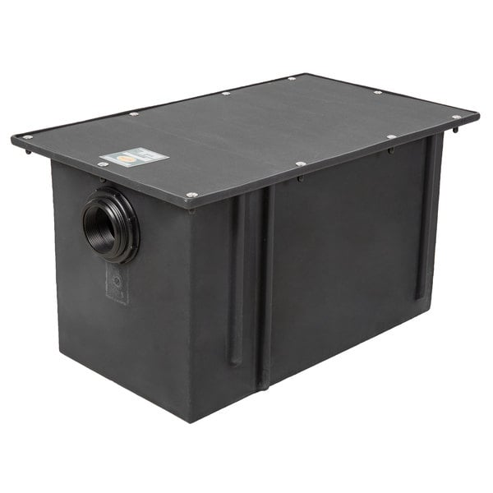

**12. Six (6) Stainless Steel Microwave Ovens**

Example: Panasonic NE-12521 stainless steel medium duty commercial microwave oven (120v/1200w)

